Name : GEETA DEVI Age : 64 Yrs Sex : F
As Advised By : DR AK SINGH MCh(NEURO) Date: November 19, 2025
===================================================================
MRI LS SPINE WITH SCREENING OF CERVICAL AND DORSAL SPINE

LUMBOSACRAL SPINE
Alignment:
Loss of normal lumbar lordosis noted, suggestive of muscle spasm or postural alteration.
Vertebral Bodies:
Normal height and marrow signal intensity except for Modic Type 2 endplate changes at D12, L2, L3, L4, and L5.
Schmorl’s node noted at D12.
Intervertebral Discs:
- Disc desiccation from L1-2 to L5-S1.
- L4-5 and L5-S1: Broad-based disc bulge with anterior thecal sac compression and bilateral exiting nerve root compression.
- Remaining lumbar discs show mild degenerative changes without significant canal or foraminal compromise.
LUMBAR CANAL AP DIAMETER AT L1 TO L5 LEVELS
LEVEL | L1-L2 | L2-L3 | L3-L4 | L4-L5 | L5-S1
AP (mm) | 12.0 | 11.8 | 11.2 | 11.3 | 13.1

Facet Joints:
Hypertrophy of facet joints at L4-5 and L5-S1, contributing to canal and foraminal narrowing.
Ligaments:
- Ligamentum flavum hypertrophy at L4-5 and L5-S1.
- Posterior longitudinal ligament hypertrophy noted at lower lumbar levels.
Spinal Canal and Neural Foramina:
- Mild to moderate canal stenosis at L4-5 and L5-S1 due to combined disc, ligamentous, and facet changes.
- Bilateral exiting nerve root compression at L4-5 and L5-S1.

CERVICAL SPINE SCREENING
Alignment:
Loss of normal cervical lordosis, possibly due to muscle spasm.
Discs:
- C4-5 and C5-6: Diffuse disc bulge with anterior thecal sac compression.
- No significant spinal canal stenosis or cord signal changes.

DORSAL SPINE SCREENING
Findings:
Dorsal vertebral bodies and discs appear normal. No evidence of disc herniation, canal stenosis, or cord signal abnormality.

IMPRESSION:
- L4-5 and L5-S1 disc bulge with anterior thecal sac compression and bilateral exiting nerve root compression.
- Loss of lumbar and cervical lordosis, likely due to muscle spasm.
- Modic Type 2 endplate changes at D12, L2, L3, L4, and L5.
- Disc desiccation from L1-2 to L5-S1.
- Schmorl’s node at D12.
- Facet joint hypertrophy and ligamentum flavum/posterior longitudinal ligament hypertrophy at L4-5 and L5-S1.
- C4-5 and C5-6 diffuse disc bulge with anterior thecal sac compression.
- Dorsal spine appears unremarkable.

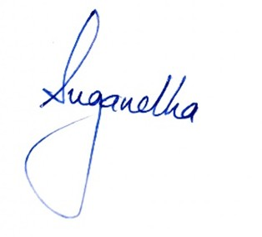
Suggested : MRI Pelvis with SI Joint Please correlate clinically

